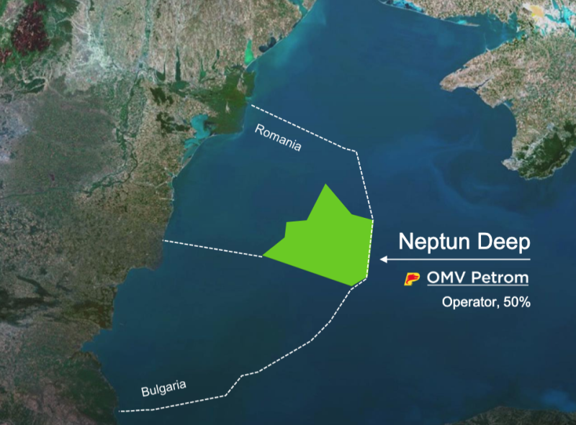
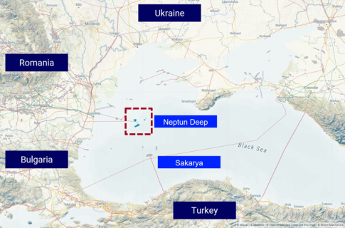
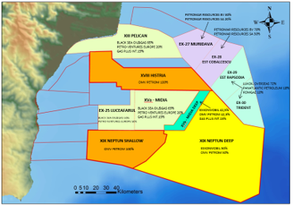
https://www.omvpetrom.com/en/about-us/what-we-do/our-projects/neptun-deep
Domino and Pelican Sud offshore platforms, ten extraction wells, and automated subsea production systems.

